HOLY WEEK – Wednesday

Reflecting on:

“Jesus’ Life:
From Nazareth to the Jordan River
and to the Desert”

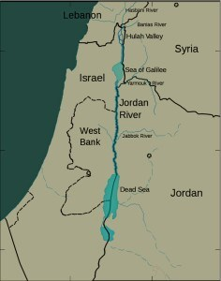

Biblical Readings:
- Mt 3: 13-17
- Mt 4: 1-11

* In the Jordan river: The baptism of Jesus in the Jordan river was the occasion when he was equipped for his public ministry by the Holy spirit and proclaimed to be the Son of God.

Jesus heard the call of God to bring the Good News of Salvation to the world, and at his baptism in the Jordan River was the proclamation of him being the Son of God. In this magnificent baptism, the image of the Trinity of God was revealed in a clear way.

* In the desert: Jesus spent forty days and forty nights in the desert to prepare his soul, spirit, mind and body for the ministry which God the Father wanted him to fulfil for the salvation of the world. He underwent three big temptations:

  - Temptation of pleasure
  - Temptation of power
  - Temptation of pride and fame
Jesus refused them all, because he chose to be the servant of God in humility and in suffering. He became a suffering servant of God the Father.

In reflecting on Jesus’ humility and self-emptiness, I asked God to help me empty myself, to mould my life into his so I can live in purity of heart, mind and life. I asked God for this, because humility is a virtue and also a great gift. It is not easy to possess. It needs to be practised every day, because pride occupies a great part of human nature.

Humility doesn’t mean that I have to be only humble towards God. It also means humility towards others in words and deeds. The first thing to practise about humility is to see goodness in others. This is a truth that I have to realise and live by if I want to be holy, good and at one with Jesus’ life. If I only see the bad side of others, pride will flourish in my mind and therefore, the image of Jesus’ humility, the model of my virtue will disappear from my life.

Asking for a Grace:

Lord Jesus,
You know what I need in spirit and life.
I entrust my mind and my life to you.
Please lead me according to your will
so I can do everything according to your will.
May I be united with you and be one with you
in Holiness
in Love
in Happiness
in Peace
in Humility
in Humiliation
and in Suffering.

I believe in you and I trust in you.
I know that you will do the best for me.
I know that you are not living my life for me,
but you journey with me, you lead me and you help me.

May every day of my life be next to your loving heart so I can live in You and You in me.
Amen.

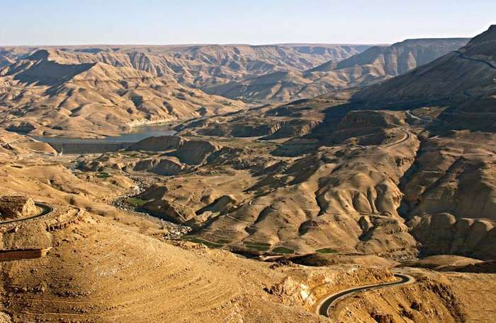

The Jordan River and the Desert

